KMS&ASM-Assignment01

AWS KEY MANAGEMENT SERVICE

- Task Title: access S3 service using KMS encryption
- Objective:
To create an Amazon S3 bucket secured with AWS KMS customer-managed encryption (SSE-KMS), upload objects into the bucket, and verify that data is encrypted at rest and accessible only to authorized IAM users.
- Prerequisites:
• AWS account with access to S3, IAM, and KMS
• IAM permissions to create users and attach policies
- Step-by-Step Implementation (With Evidence):
Step 1: Create an S3 bucket
• Console path: Amazon S3 → Buckets → Create bucket
• Explanation: Created a new S3 bucket named kms-assignment01 in the Asia Pacific (Sydney) region with ACLs disabled and default settings.
Evidence: 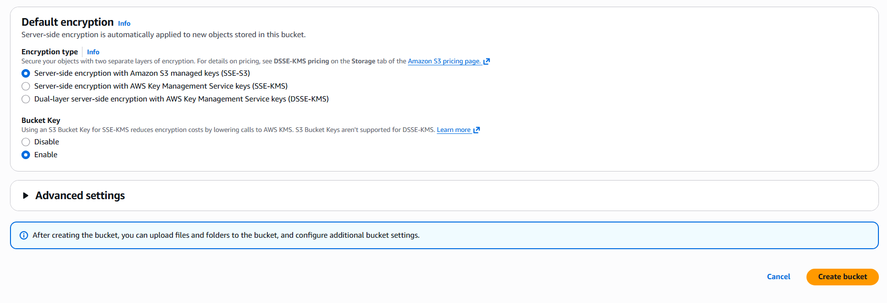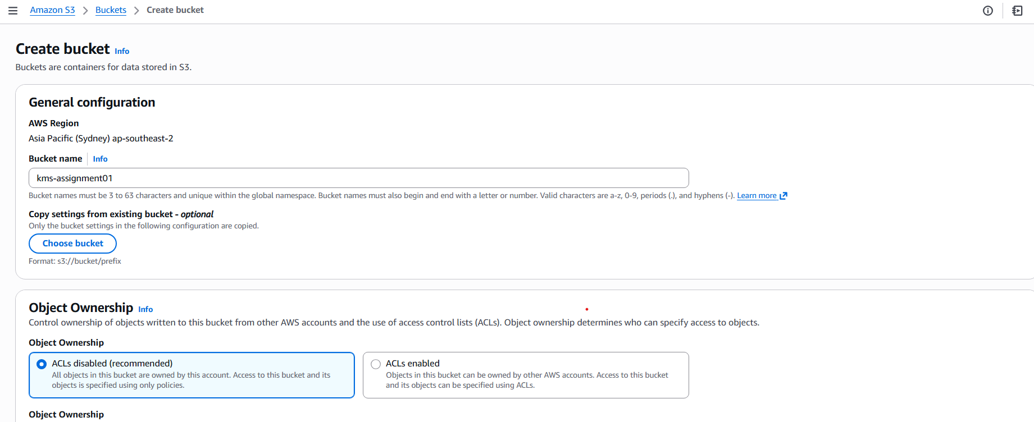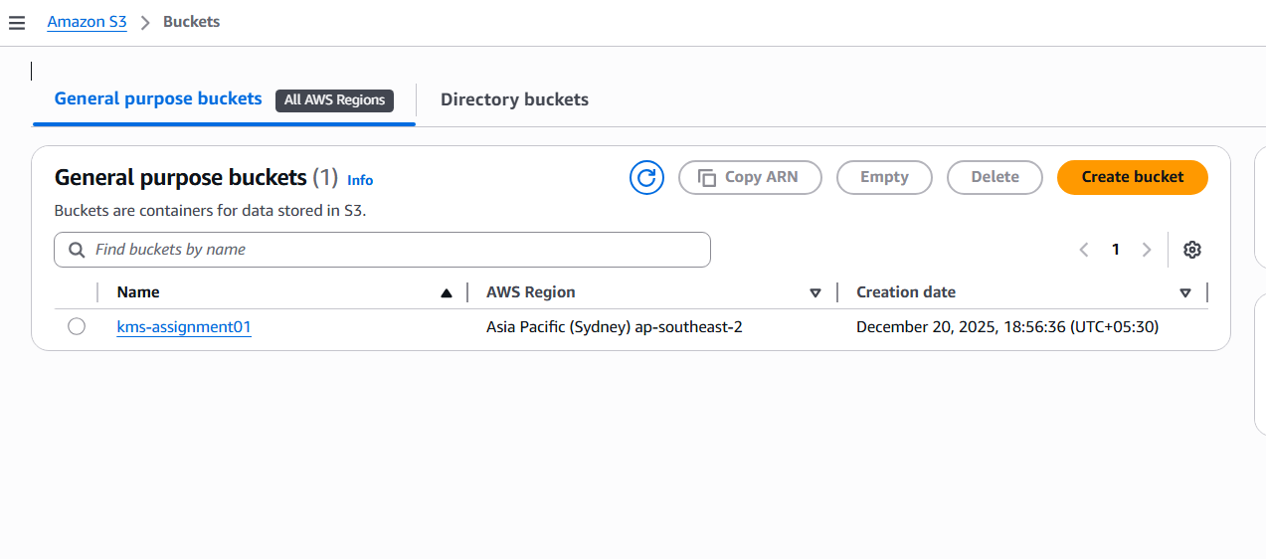
Step 2: Upload objects to the S3 bucket
• Console path: Amazon S3 → Buckets → kms-assignment01 → Upload
• Explanation: Uploaded text files into the bucket to validate object storage functionality.
Evidence: 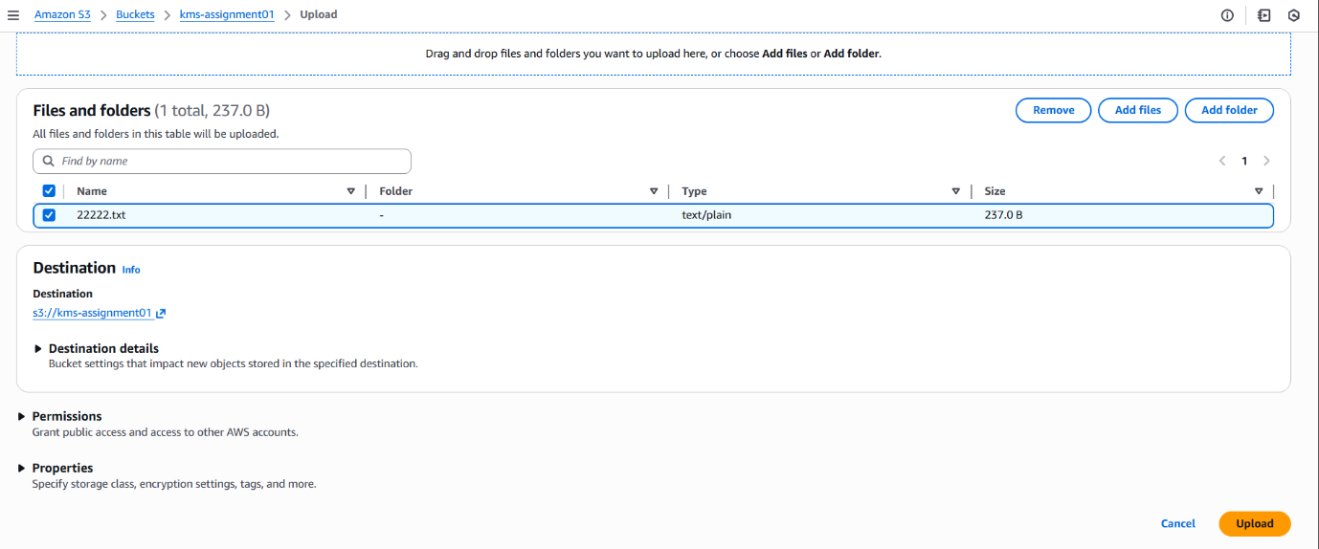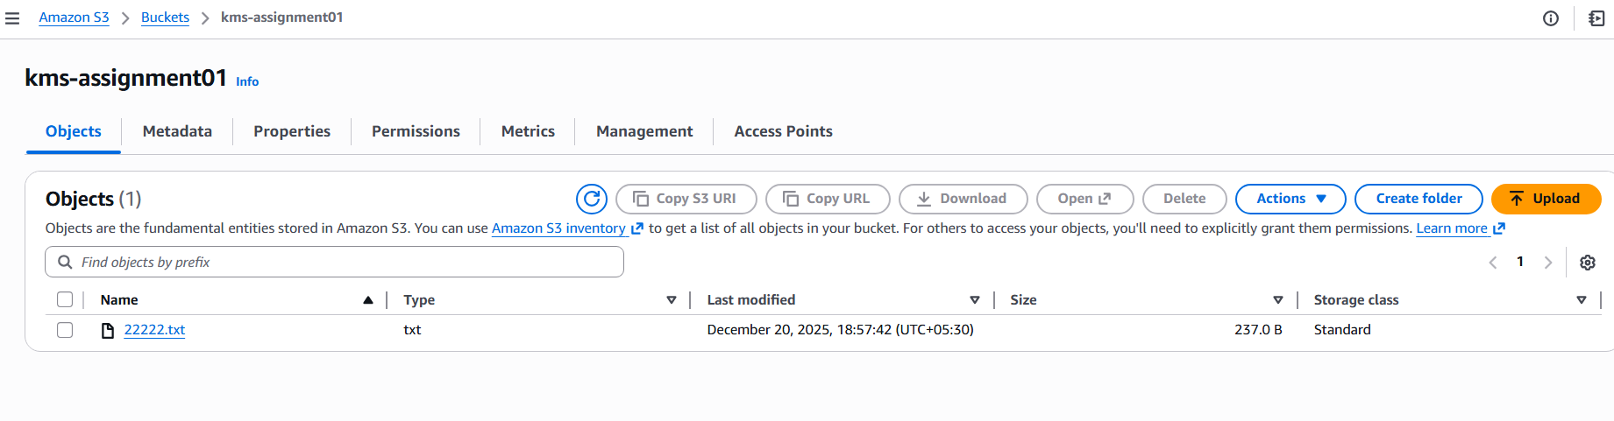Step 3: Create an IAM user
• Console path: IAM → Users → Create user
• Explanation: Created IAM user KMS-Assignment01 with AWS Management Console access and attached the AmazonS3FullAccess policy.
Evidence: 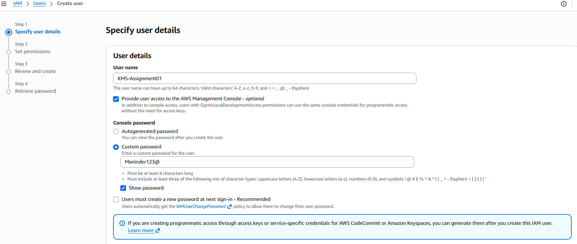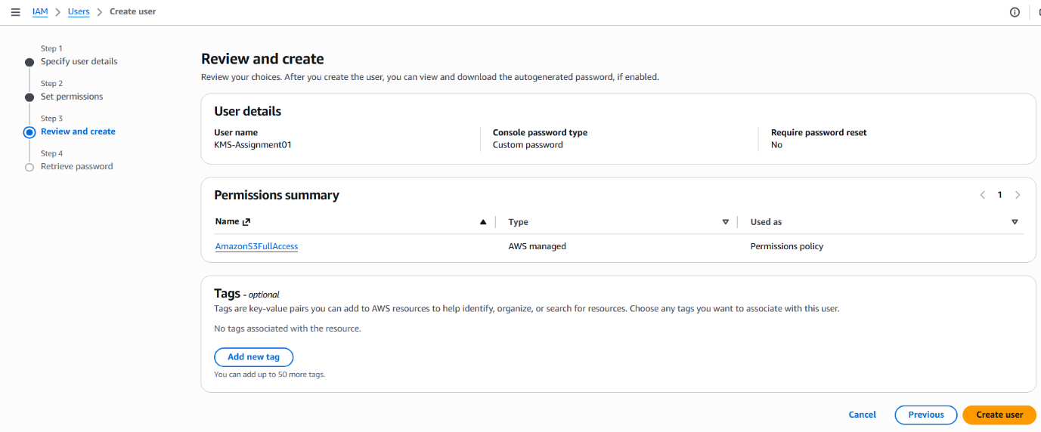Step 4: Create a customer-managed KMS key
• Console path: KMS → Customer managed keys → Create key
• Explanation: Created a symmetric KMS key for encrypt and decrypt operations and assigned KMS-Assignment01 as both key administrator and key user.
Evidence: 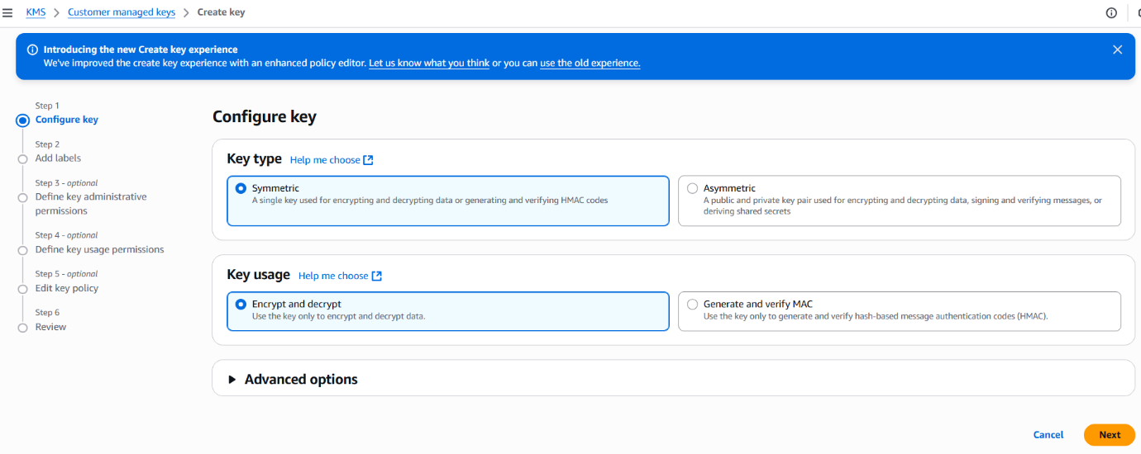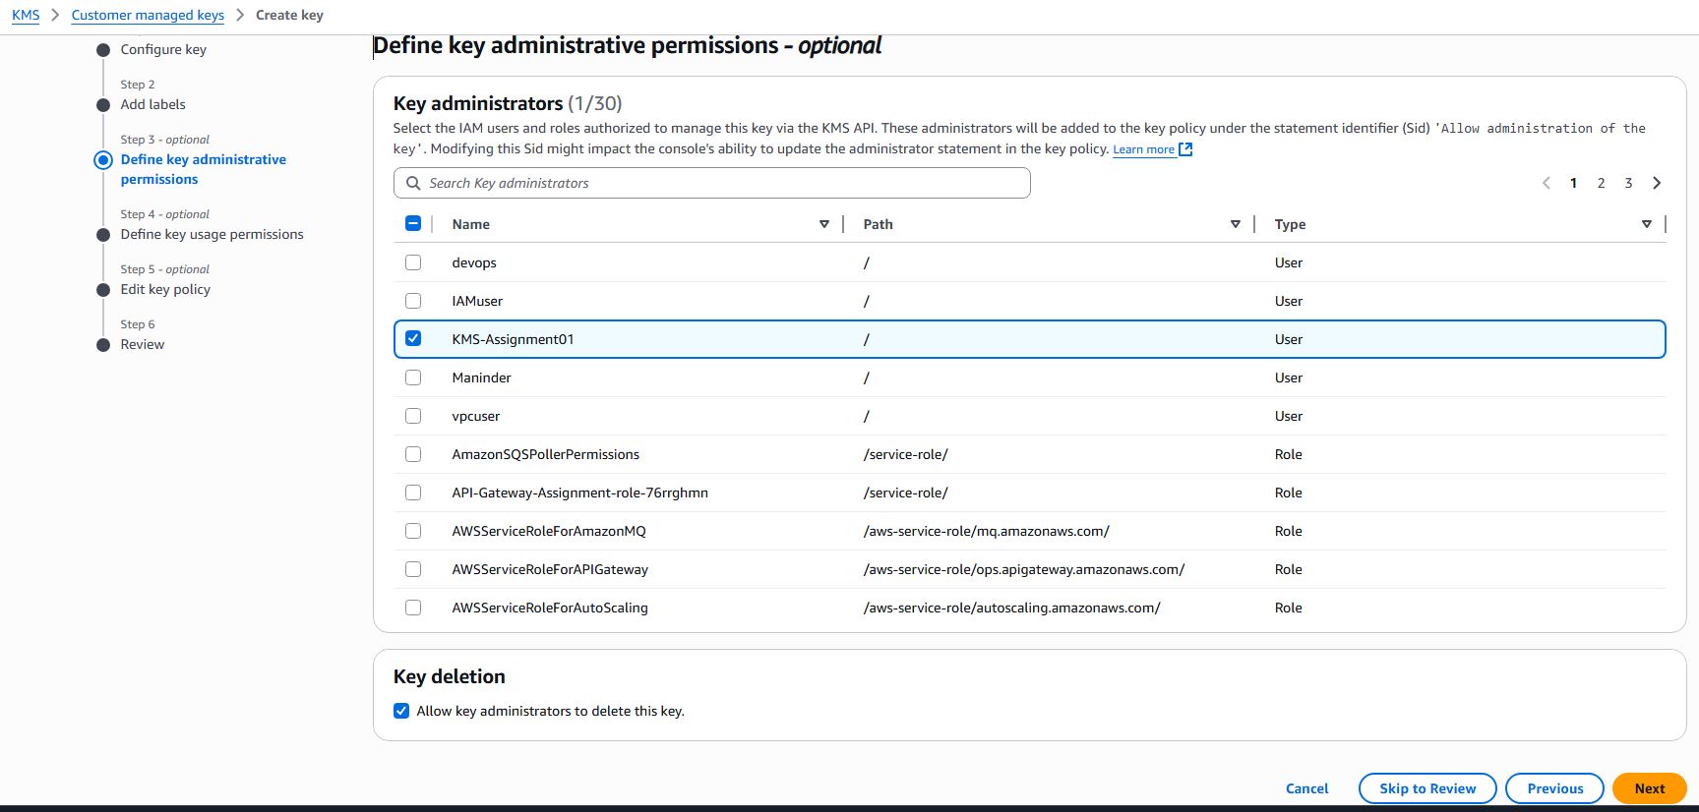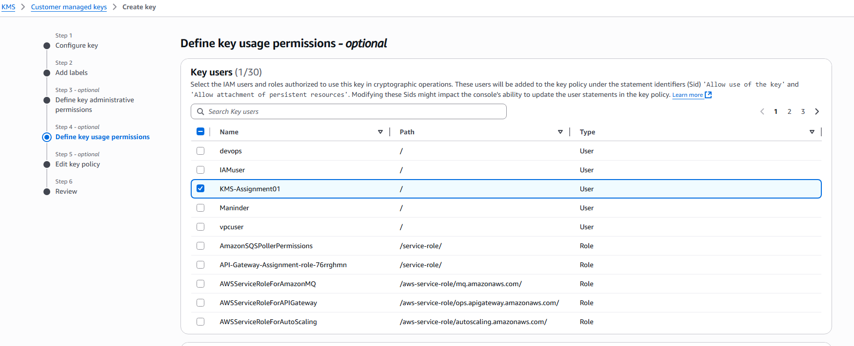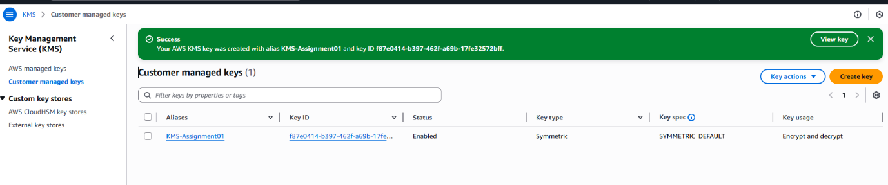
Step 5: Configure S3 bucket encryption using KMS
• Console path: Amazon S3 → Buckets → kms-assignment01 → Properties → Default encryption → Edit
• Explanation: Enabled Server-Side Encryption with AWS KMS keys (SSE-KMS) and selected the customer-managed KMS key. Bucket Key was enabled to reduce KMS costs.
Evidence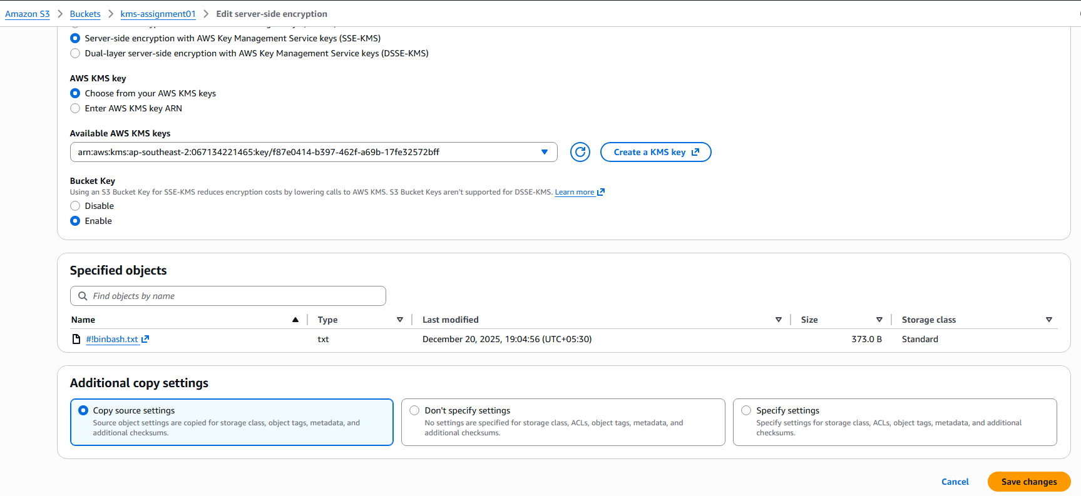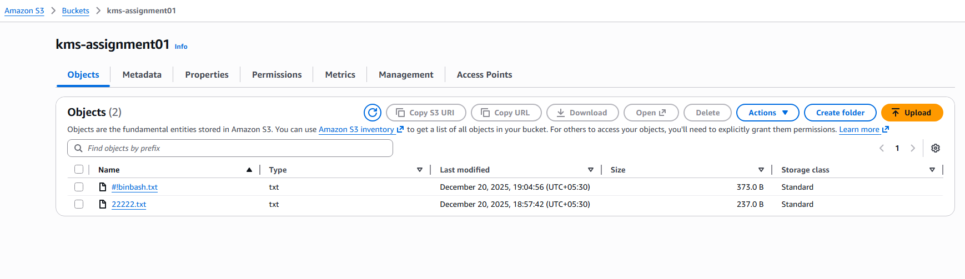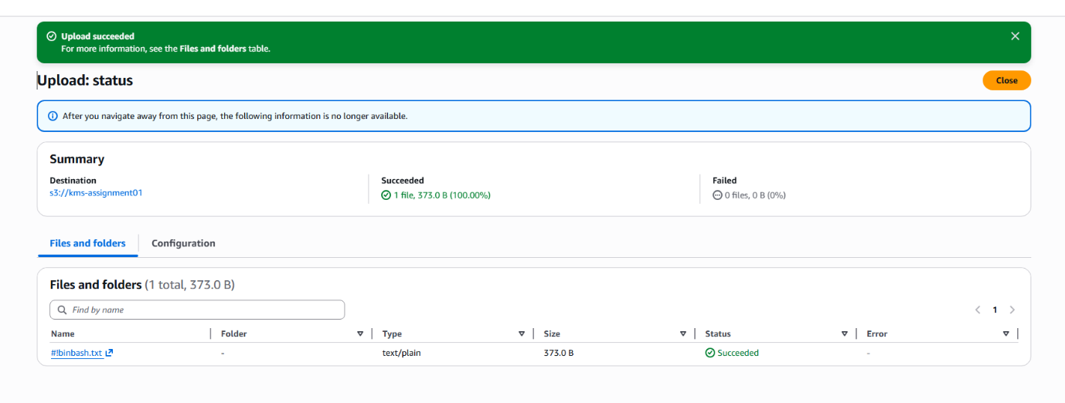Step 6: Verify encrypted object access
• Console path: Amazon S3 → Buckets → kms-assignment01 → Objects → Select object
• Explanation: Accessed the uploaded object to confirm it is readable through the console while being encrypted at rest using KMS.
Evidence: 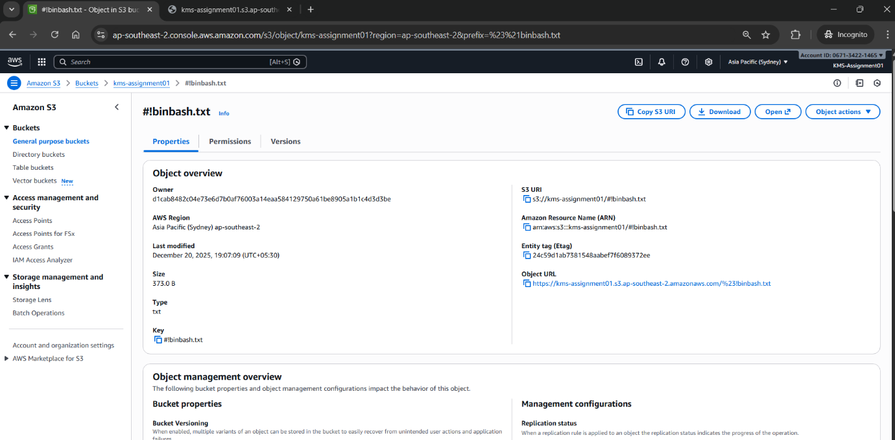Validation Steps (Mandatory, With Evidence):
Access Check
Example: IAM user access validation
Evidence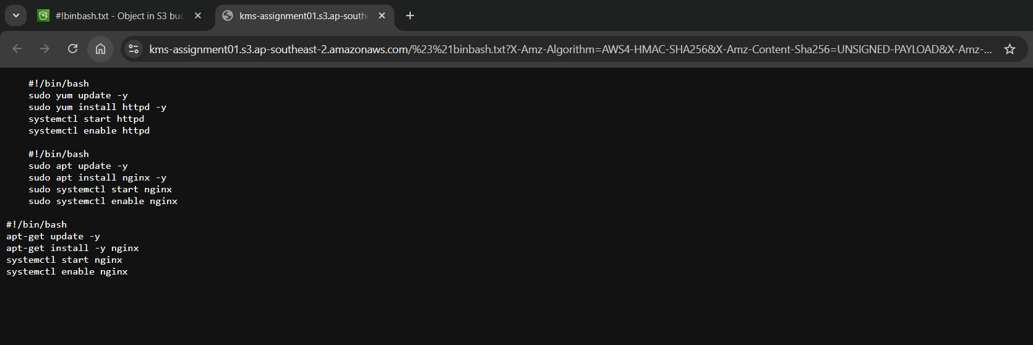
Issues Faced (Optional):
Initially, objects uploaded before enabling SSE-KMS were encrypted with default settings. This was resolved by updating bucket encryption and re-uploading objects to ensure KMS encryption.
- Conclusion:
Successfully configured Amazon S3 with AWS KMS customer-managed encryption, validated secure object storage, and confirmed controlled access using IAM permissions.
AWS SECRETS MANAGER

- Task Title: Access database using secret created using credentials like user’s name and password through Amazon Secret Manager
- Objective:
To create an Amazon RDS database with credentials managed by AWS Secrets Manager, encrypted using a customer-managed KMS key, and validate secure storage and retrieval of database credentials.
- Prerequisites:
• RDS, Secrets Manager, KMS, and IAM
- Step-by-Step Implementation (With Evidence):
Step 1:
• Console path / CLI command: AWS Console → KMS → Customer managed keys
• Explanation: The existing KMS key KMS-Assignment01 was selected to encrypt Secrets Manager secrets and RDS storage.
Evidence: 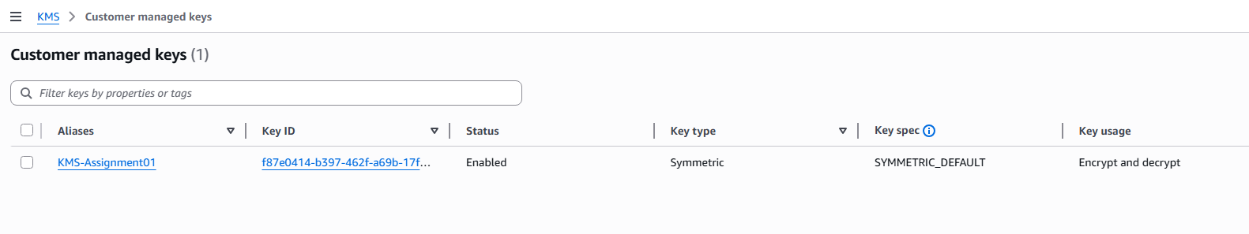
Step 2:
• Console path / CLI command: AWS Console → RDS → Databases → Create database
• Explanation: A MariaDB database (db.t4g.micro) was created using Free Tier. Master credentials were set to be managed by AWS Secrets Manager and encrypted using KMS-Assignment01.
Evidence: 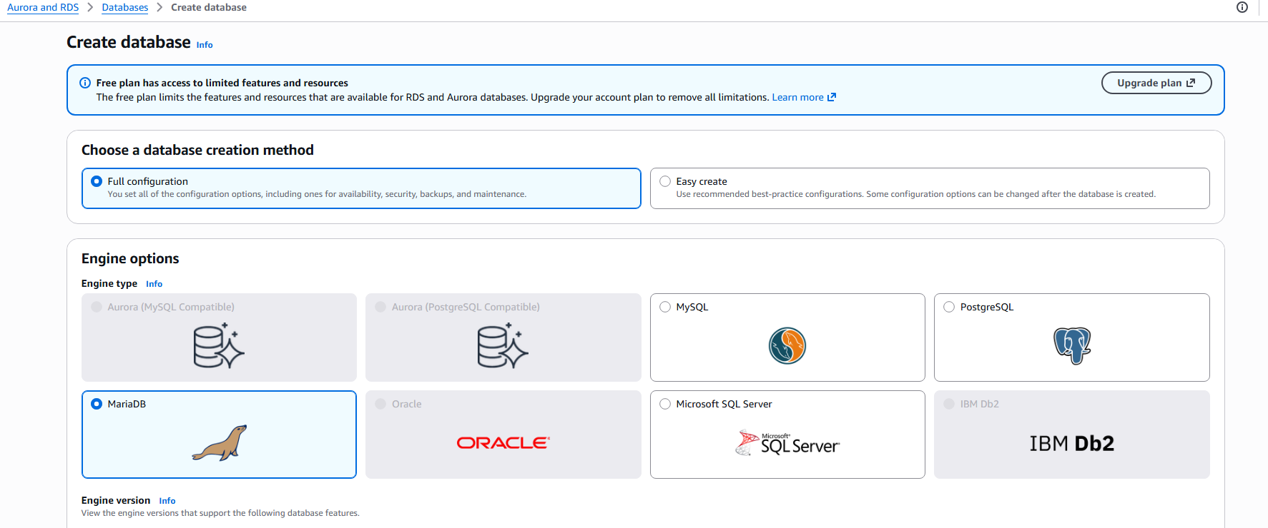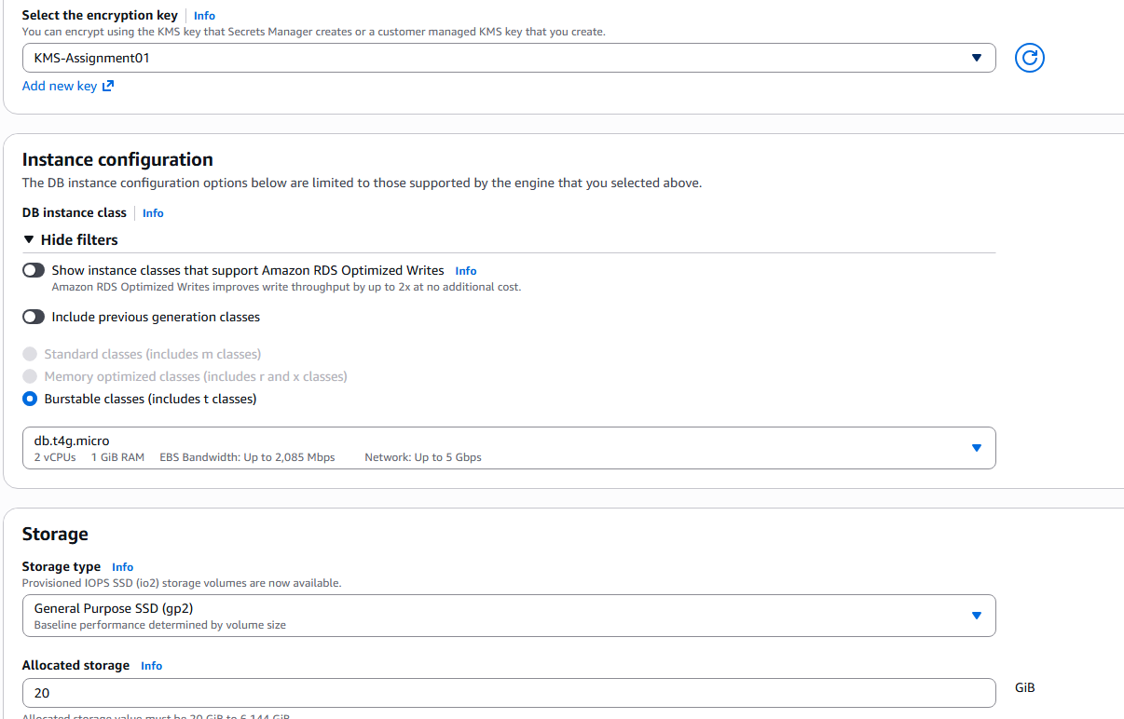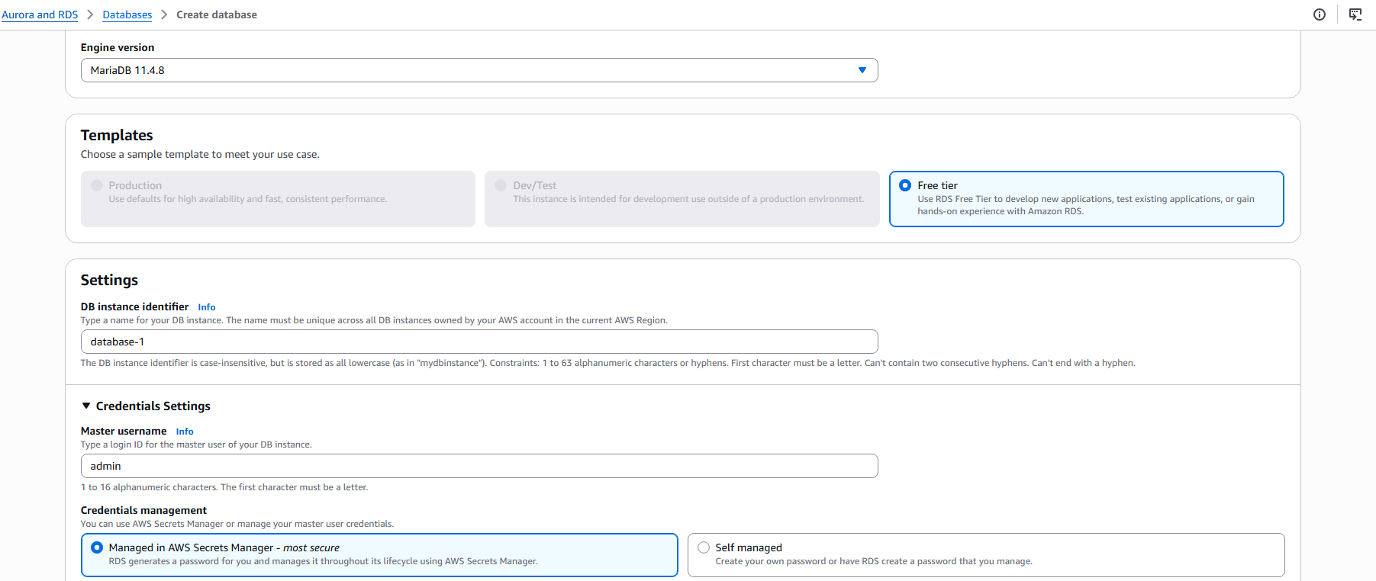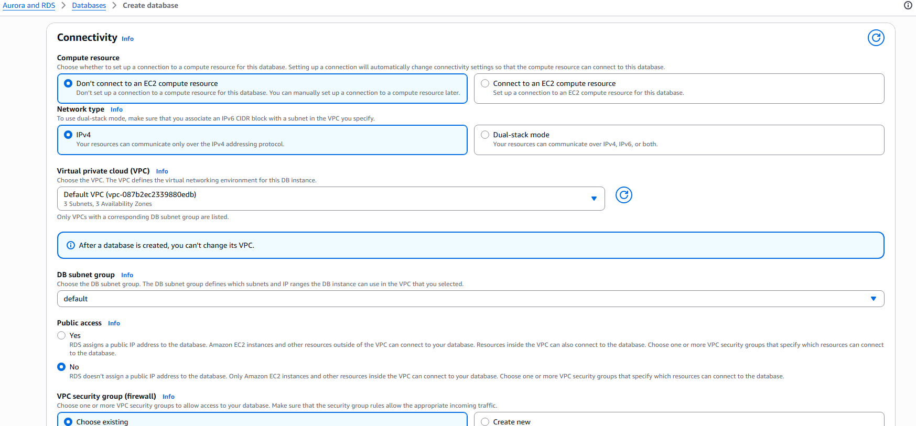
Step 3 (If applicable):
• Console path / CLI command: AWS Console → Secrets Manager → Secrets
• Explanation: Secrets Manager automatically created a secret containing the database username and password, encrypted using the customer-managed KMS key.
Evidence: 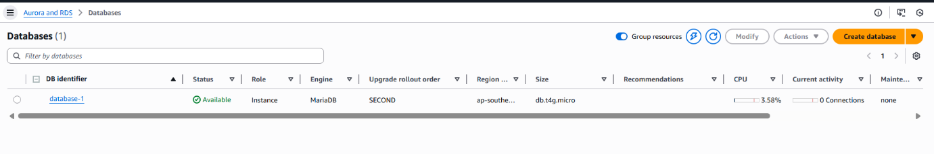
- Validation Steps (Mandatory, With Evidence):
Access Check
Example: Verify secret encryption
Evidence: 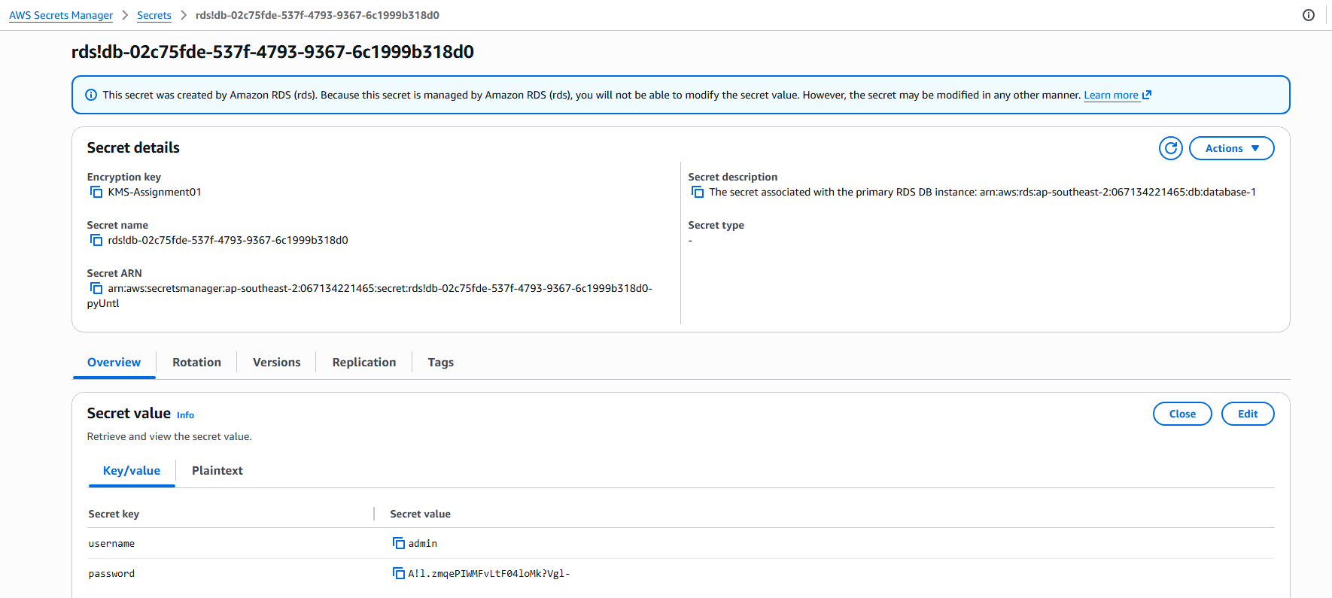Issues Faced (Optional):
No issues encountered. Secrets Manager automatically handled credential creation and encryption.
- Conclusion:
Successfully created an RDS database with credentials securely stored and encrypted in AWS Secrets Manager using a customer-managed KMS key.

